1. Which are the top three variables in your model which contribute most towards the probability of a lead getting converted?

Ans:

From the below coefficient values taken from the final model that is used for prediction, we can say that

* **Occupation_Working Professional**
* **Last Notable Activity_Had a Phone Conversation**
* **Lead Origin_Lead Add Form**

Are the three variables that contribute most towards the probalities of a lead getting converted.

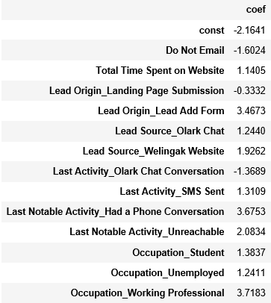

1. What are the top 3 categorical/dummy variables in the model which should be focused the most on in order to increase the probability of lead conversion?

As per the above table, the top 3 categorical/dummy variables that contribute the most towards the probability of a lead getting converted are also :

* **Occupation_Working Professional**
* **Last Notable Activity_Had a Phone Conversation**
* **Lead Origin_Lead Add Form**

1. X Education has a period of 2 months every year during which they hire some interns. The sales team, in particular, has around 10 interns allotted to them. So during this phase, they wish to make the lead conversion more aggressive. So they want almost all of the potential leads (i.e. the customers who have been predicted as 1 by the model) to be converted and hence, want to make phone calls to as much of such people as possible. Suggest a good strategy they should employ at this stage.  
   Ans:

The leads that are predicted are based on threshold that we choose. In order to increase the number of leads, we need to decrease the threshold value. This can be noted using two metrics namely **Specificity** and **Sensitivity.**

**Specificity** is defined as the ratio of total number of actual conversions that are predicted to the total number of actual conversions

**Sensitivity** is defined as the ratio of total number of non-conversion that are predicted to the total number of actual non-conversions

X Education has more man power for a period of 2 months and they wish to increase the lead conversion more aggressive by wanting almost all of the potential leads.

In this case we need to decrease the threshold and thus generate more leads. This will ensure the Sensitivity is very high which will ensure almost all the leads who are likely to convert are identified correctly and the agents can make calls as many people as possible.

1. Similarly, at times, the company reaches its target for a quarter before the deadline. During this time, the company wants the sales team to focus on some new work as well. So during this time, the company’s aim is to not make phone calls unless it’s extremely necessary, i.e. they want to minimize the rate of useless phone calls. Suggest a strategy they should employ at this stage.

Ans:

Similar to the above logic, since X Education has already reached its target for a quarter and doesn’t want to make phone calls unless it’s extremely necessary, i.e. they want to minimize the rate of useless phone calls, we can choose a **higher threshold value for Conversion Probability**.

This will ensure the specificity is very high, which will in-turn ensure that leads which are at the brink of converted or not converted and will reduce the number of leads. As a result the agents won’t have to make unnecessary phone calls and can focus on some new work.